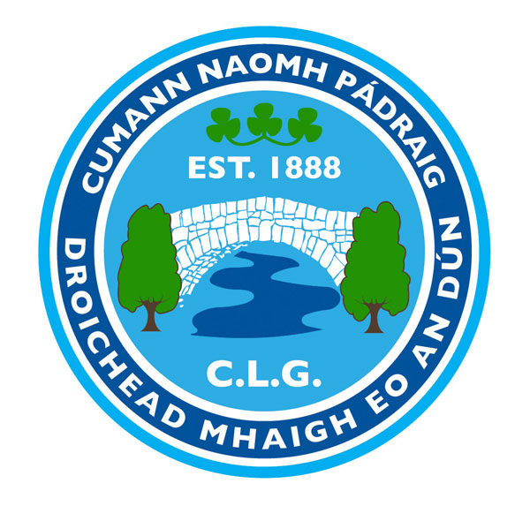

AGM NOMINATION FORM 2020

Mayobridge GAC Club’s Annual General Meeting will be held on Tuesday 8th December 2020 at 7.30pm.

All fully paid members are entitled to nominate (nominee must be asked), and vote. All nomination papers must be signed by the member submitting the nominations.
Nominations, motions and Recommendations must be returned to Tomás Ó hÍr (Rúnaí, Droichead Mhaigh Eo) on or before Sunday 22nd November 2020 returns may also be sent by email to secretary.mayobridge.down@gaa.ie.

Only fully paid up members can nominate, be nominated and vote

Positions for election: Your Nomination

Uachtarán/ President………………… Tom O’Hare

Leas-Uachtarán/ Vice-President…… Johnny McConville

Cathaoirleach/ Chairperson…………………………………………………………………………….......

Leas-Cathaoirleach/ Vice Chairperson…………………………………………………………………….

Rúnaí/ Secretary……………………………………………………………………………….......................

Leas-Rúnaí/ Assistant Secretary……………………………………………………………………............

Cisteoir/ Treasurer………………………………………………………………………………...................

Leas-Cisteoir/ Assistant Treasurer…………………………………………………………………............

Oifigeach na bPáistí/ Children’s Officer…………………………………………………………………...

Cláraitheoir/Registrar…………………………………………............…………………………………….

Toscairí Bhord an Contae/ Delegates to County Board.......………......…………………………………

Oifigeach Gaeilge…………………………………......................................…………………………………

Oifigeach Cultúrtha/ Cultural officer……………………………………...………………………………

Oifigeach Caidrimh Poiblí/ P.R.O.…………………………………………………………………………

Oifigeach Sláinte/ Health & Well-Being Officer..........................................................................................

Oifigigí Oiliúna/ Coaching Officers..………………………………………………………………………

Ionadaí na n-Imreoirí (Fir)/ Players’ Representative (Male)……………………...………………..……

Ionadaí na n-Imreoirí (Mná)/ Players’ Representative (Female)………………………………………..

Oifigeach Scoile/ School Liaison Officer…...……………………………………………………………...

Oifigí Eile/ Additional Officers..............……………………………………………………………………

Signed………………………………Print Name……………………..Date…….....

MOTIONS & RECOMMENDATIONS OVERLEAF PLEASE

